# Lesson 26 单词讲解

1. paint v. 画，在 上涂油漆，涂抹

paint + pictures / a house

Paint a house 刷油漆

n. 涂料，油漆，化妆品

painting n. 油画，水彩画，绘画艺术

1. appreciate v. 鉴赏，欣赏；感激，感谢

appreciate modern pictures I really appreciate your help.

~ + doing sth.

1. hang v. 悬挂，吊 (hung, hung)

hang this picture on the wall

绞死，上吊 (hanged, hanged)

1 [art](http://dict.cn/art.htm)[ɑ:t] n.艺术

2 [critic](http://dict.cn/critic.htm) ['kritik] n.评论家

3 [paint](http://dict.cn/paint.htm) [peint] v.画

4 [pretend](http://dict.cn/pretend.htm) [pri'tend] v.假装

5 [pattern](http://dict.cn/pattern.htm) ['pætn] n.图案

6 [curtain](http://dict.cn/curtain.htm) ['kə:tən] n.窗帘，幕布

7 [material](http://dict.cn/material.htm)[mə'tiəriəl] n.材料

8 [appreciate](http://dict.cn/appreciate.htm)[ə'pri:ʃieit] v.鉴赏

9 [notice](http://dict.cn/notice.htm) ['nəutis] v.注意到

10 [whether](http://dict.cn/whether.htm)['weeə] conj.是否

11 [hang](http://dict.cn/hang.htm) [hæŋ] v.悬挂，吊

12 [critically](http://dict.cn/critically.htm)['kritikəli] ad.批评地

13 [upside](http://dict.cn/upside.htm)['ʌpsaid] 上下颠倒地

宾语从句

一般现在时／现在进行时宾语从句

含义：

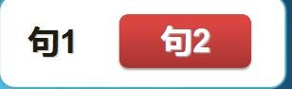

宾语从句写法：

陈述句变宾语从句？



宾语从句

# Lesson 26 课文&语法讲解

写法：

陈述句变宾语从句？

You are right.



I know (that) you are right

宾语从句写法：

陈述句变宾语从句？

They understand modern art.

Many people pretend (that) they understand modern art.

pretend 是个及物动词 后面接着宾语，绿色部分做宾语

塞到pretend 后面，就是个宾语从句

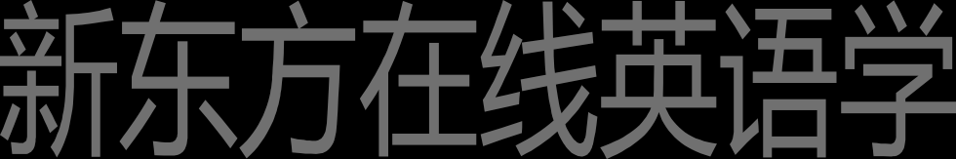宾语从句写法：

特殊疑问句变宾语从句？

What is a picture 'about'?



They always tell you what a picture is 'about'

Tell 后面接宾语you you后面又有东西 所以这个句子是主谓双宾

但是第二个宾语是个特数疑问句。得把特数疑问句改一下

改成what a picture is 'about a picture 是主语，is是谓语

宾语从句写法：

一般疑问句变宾语从句？

什么是一般疑问句？回答yes或者no

一般疑问句得语序要调整。主语提前 动词放后

Are my pictures good or not?



She always tells me whether / if my pictures are good or not

宾语从句写法：

1.Many people pretend that they understand modern art. 2.They always tell you what a picture is 'about'.

3.She always tells me whether my pictures are good or not.

宾语从句大总结：句子作宾语，一个句子有 主 谓 宾 但是这个宾语是个句子 但是这个句子有很多种，有以上提到得三种

所以句子需要改造一下在去做宾语



练习 宾语从句 连接词+陈述句

我承诺我会帮助你。

I promise that I will help you.

你从来没告诉过我，你对我的电脑做了什么。

You never told me what you had done to my computer.

我想知道什么时候我们将会出发。

I wonder when we will set out.

他们不知道他们是否会按时完成工作。

They don’t know whether they will finish the work on time.

我想知道什么时候我们将会出发。

I wonder when we will set out.

你能告诉我什么时候我们将会出发吗?

Can you tell me when we will set out ?

宾语从句位置：

Many people pretend that they understand modern art. They always tell you what a picture is 'about'.

He was astonished at what he found.

1. I am an art student and I paint a lot of pictures.

并列句 一般现在时

1. Many people pretend that they understand modern art.
2. They always tell you what a picture is 'about'.

宾语从句

1. We like them in the same way that we like pretty curtain material.
2. I think that young children often appreciate modern pictures better than anyone else.
3. sister is only seven, but she always tells me whether my pictures are good or not.
4. 'What are you doing?' she asked.
5. 'I'm hanging this picture on the wall,' I answered.
6. 'It's a new one. Do you like it?'

# Lesson 26 知识拓展

本课重点: 宾语从句

宾语从句

He always finds that someone has parked a car outside his gate. I asked him what it was.

He asked his doctor to tell him _whether his operation had been successful.

宾语从句

我认为爱是世界上最伟大的事情。

I think (that) love is the greatest thing in the world.

宾语从句

态度决定人们是否将会成功。

Attitude decides whether people will succeed.

宾语从句

我昨天问他我在哪里可以买到那本书。

I asked him where I could buy/get the book.

本课重点: 宾语从句